# IST Labs: Collect Printer Usage Data Procedure

When you change the printer toner cartridge, you should also update the Google sheet (via the student worker portal, under "Resources") to record which printer had its toner replaced, who did it, and how many pages had been printed in total.

After changing the toner cartridge, press the menu button

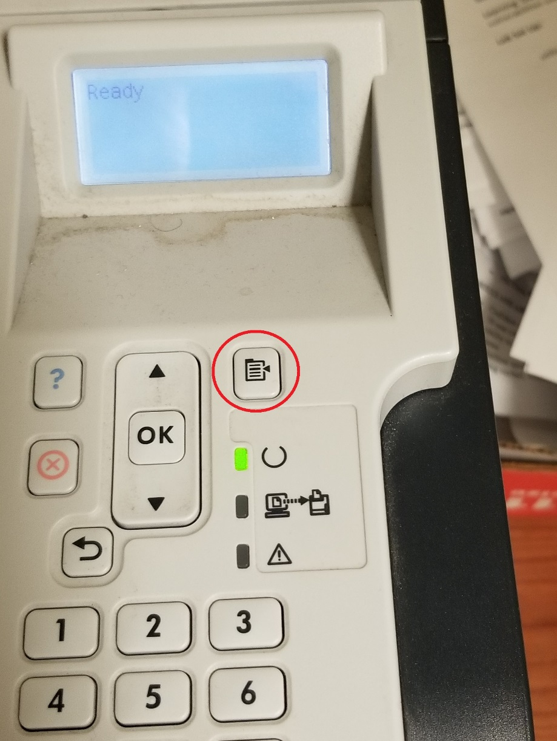

You should then see the first menu screen:

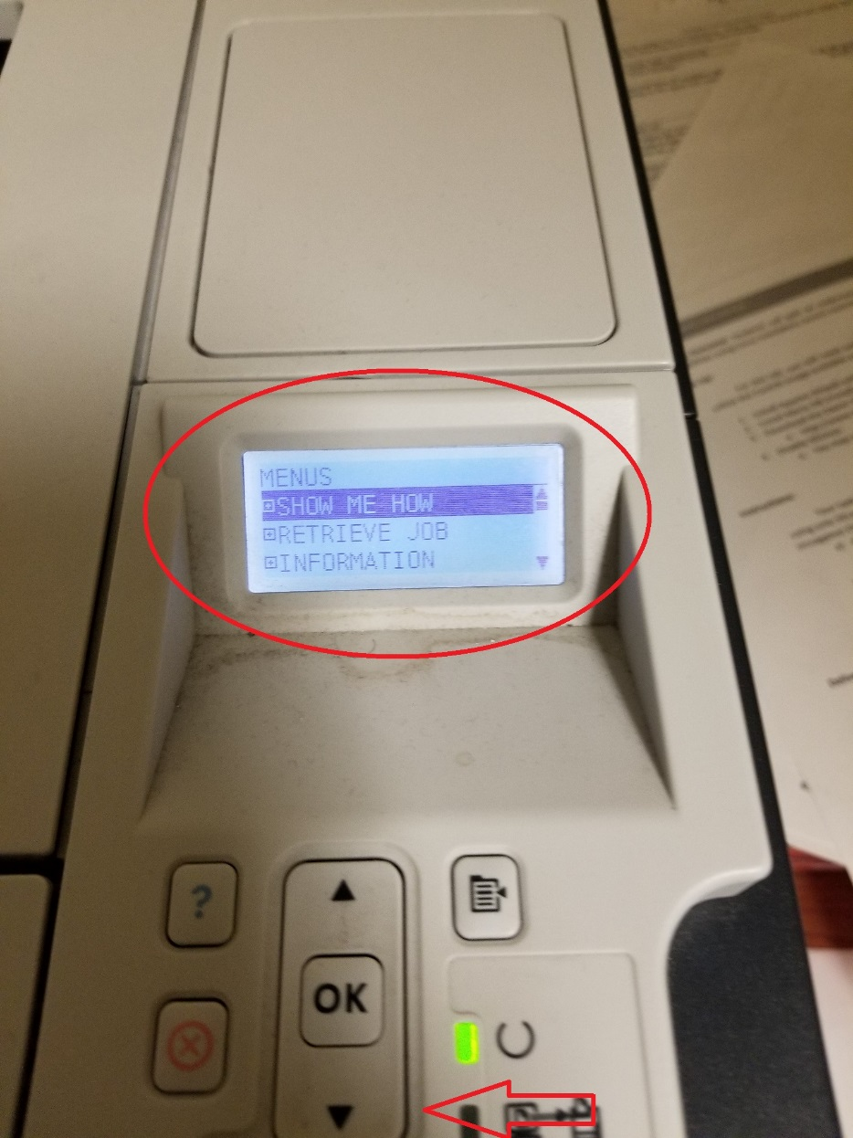

Use the arrow keys (above and below the "OK" button) to scroll down to the "information" menu item, then press OK to select that submenu.

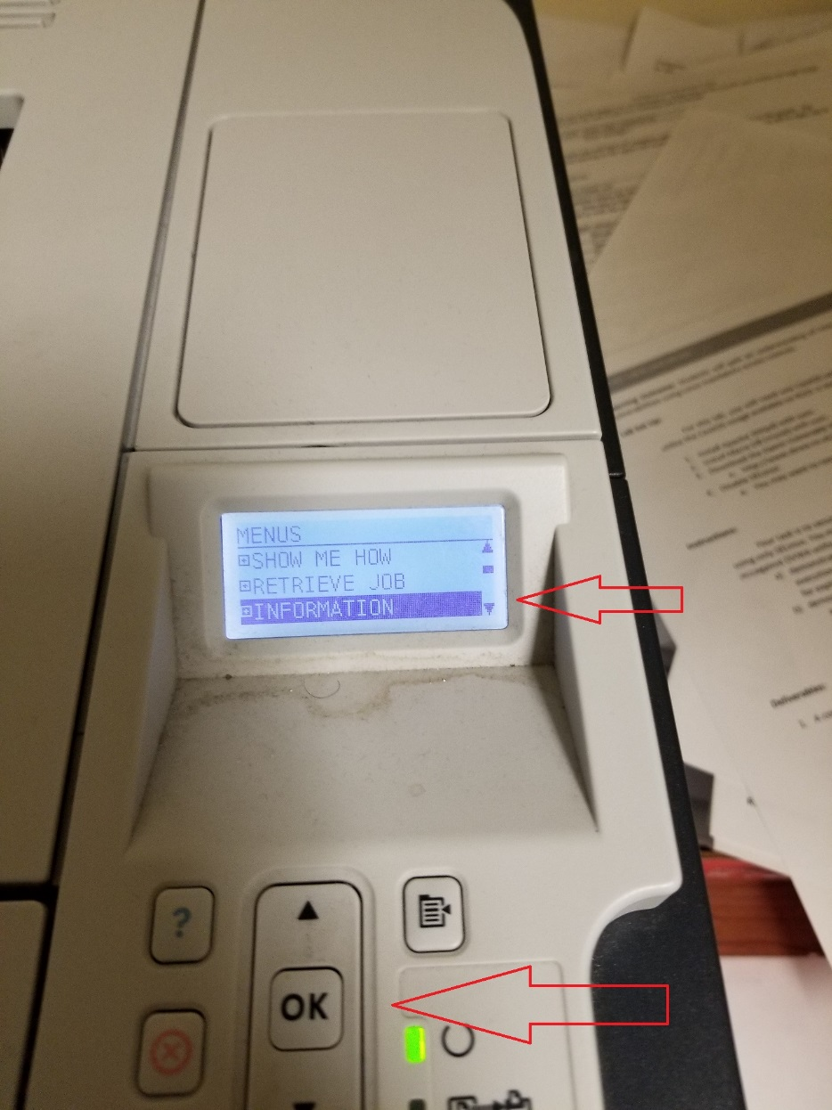

In the information menu, scroll down to find the "Print Usage Page" menu item, and then press OK:

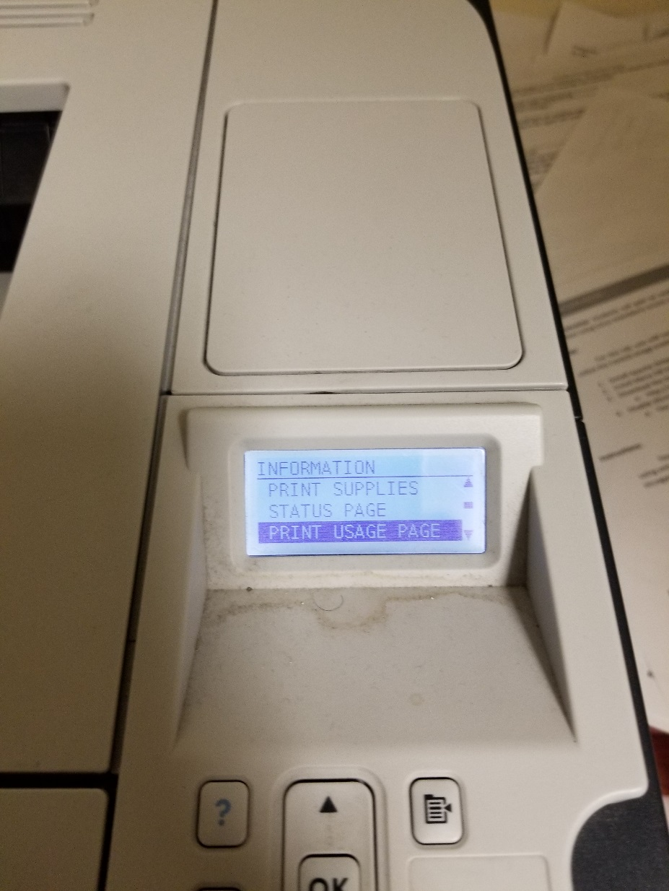

That will print two pages of information (sadly, we only need one line of the information, near the bottom on page one:

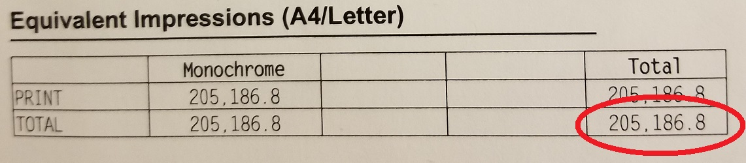

That is the number (you can round to the nearest integer) that needs to be recorded in the Google sheet (the data below is from a few days ago):

